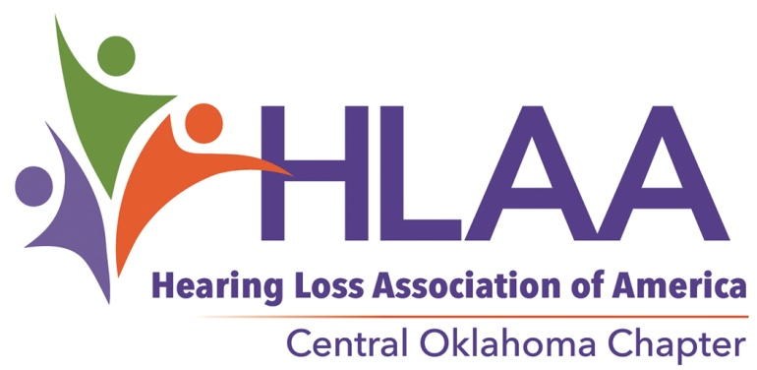
PO Box 42801
Oklahoma City, Oklahoma 73123

FOR IMMEDIATE RELEASE
Contact: Ron Hendricks, Media
Phone: 405/550-3224
Email: ron-gmi@swbell.net

[Demise of Hearing Helpers Room]

I am sorry to announce the loss of our beloved Hearing Helpers Demonstration Room. It was closed as of the first of June 2020.
After 22 years, Integris decided to discontinue our association for a variety of reasons, including budget concerns and COVID19. The HHR was filled with important hearing assistive technology to help those of us with hearing loss live better at home and work. Countless people visited through the years and our volunteers helped each one.
We are now looking for another major benefactor. If you know of such a possible sponsor, a beneficent corporation or individual please let us know.
We hope to restart monthly meetings in September so please stay tuned.
In other news your Hearing Loss Association of America Central Oklahoma Chapter (HLAA COC) is still working to assist Oklahomans with hearing loss to live successfully in a hearing world. Our scholarship program is still in full swing. For the fifth year n a row we have awarded scholarships to Oklahoma students with hearing loss. This year we awarded three scholarships for $1,500 each. We hope to do the same next year. The drive to equip public gathering spaces through Hearing Loops, is still on-going.
We are an all volunteer run 501 C(3) organization with no paid officers.
Check out our Facebook page @HLAA CentralOklahomaChapter (Note, there is a space between words HLAA & Central and no other spaces. The current page is the one with a green state of Oklahoma logo) and visit our website:OklahomaHearingLoss.org.

The Hearing Loss Association of America Central Oklahoma Chapter is a 501(c)3 tax exempt organization. Out Chapter is run entirely by volunteer, there are no paid positions. [the HLAA hopes to open the world of communication to people who have a hearing loss by providing information, education, support and advocacy.]

###

If you would like more information about this topic, please call COC HLAA Chair Ana Covey at 405-640-5152, or emailana@assist2hear.com

