OU student receives scholarship from Hearing Loss Association of America

The Central Oklahoma Chapter of the Hearing Loss Association of America announced in a press release that an OU student received one of two $1,000 scholarships.

Peter Hardt is an accounting senior who was born with bilateral profound hearing loss. According to the release, Hardt was the first child in Oklahoma to have hearing loss detected by a newborn hearing screening.

“I think the most important (thing) for people to know about kids with hearing loss is that they are normal kids who want things normal kids want to do,” Hardt said. “I'm proud to give a lot of people a face to put to hearing loss.”

To qualify for the scholarship, applicants must have documented hearing loss, be a resident of Oklahoma, plan to attend an institute of higher education and submit an essay about how hearing loss has affected their lives.

“Getting this scholarship was a great feeling because it feels like a confirmation of everything I’ve worked for,” Hardt said.

Sharon Hendricks, chair of the scholarship committee, said Hardt got their attention because of his “outstanding” work ethic.

“In (Hardt’s) case, he’s just an unbelievable go-getter,” Hendricks said.

University of Central Oklahoma criminal justice student Haleigh Scott received the organization’s other scholarship, according to the release.

The chapter is taking applications for next year’s $1,500 scholarship award until April 6. Interested students can visit the organization’s website for more information.
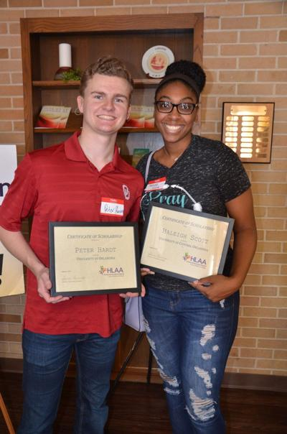
The Central Oklahoma Chapter of the Hearing Loss Association of America awarded two $1,000 scholarships to OU accounting student Peter Hardt (left) and UCO criminal justice student Haleigh Scott.
Beth Wallis, news reporter. OUDAILY 2/7/2020

