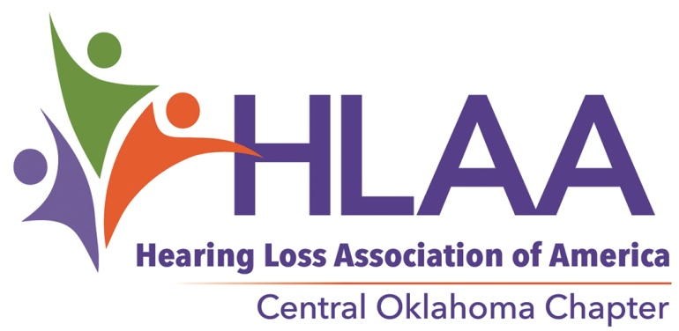
PO Box 42801
Oklahoma City, Oklahoma 73123

FOR IMMEDIATE RELEASE
Contact: Ron Hendricks, Media
Phone: 405/550-3224
Email: ron-gmi@swbell.net

[Scholarship Applicants Sought]

Scholarship Applicants Sought

Students with hearing loss who will be attending higher education this coming fall may apply. Hearing Loss Association of America Central Oklahoma Chapter (HLAA COC) is offering scholarships of $1,500 each to students who qualify. Application deadline is 5PM April 6, 2020.
Oklahoma students of all ages are eligible. A brief essay & audiogram are required as well as a completed application & acceptance to an Oklahoma institution of higher learning. Applications are available online at WWW.OklahomaHearingLoss.org. HLAA COC exists to assist Oklahoman with hearing loss live successfully in the hearing world. HLAA COC has been serving for 28 years in the Oklahoma City area by educating members with tips and hints for better hearing and areas where danger to hearing exists. Hearing loss is an invisible condition but it is thought that 13-15% of the population suffers from mild to extreme hearing loss. The major medical concern of returning veterans is hearing loss. The World Health Organization tells us that hearing loss will be an even larger world wide problem in the immediate future. In addition to the scholarships, HLAA COC offers the Hearing Helpers Room for demonstration of hearing assistive devices of all sorts with the option of in home trial. HLAA COC is working to secure access for all with hearing loss by encouraging the installation of hearing loops in public gathering places. Monthly meetings are a place where all are welcome and it is OK if you don’t hear well because the meeting is looped & captioned so you can see as well as hear what is being said. Meetings are held on the third Thursday, 11:30 – 1PM including a lite lunch, at the Will Rogers Garden Exhibition Hall, 3400 NW 36. There is no admission charge. HLAA COC is 501 (c) 3 tax exempt, all volunteer, organization. We have no paid staff. If you have a hearing loss or know and love someone who does, you are welcome.

The Hearing Loss Association of America Central Oklahoma Chapter is a 501(c)3 tax exempt organization. Out Chapter is run entirely by volunteer, there are no paid positions. [the HLAA hopes to open the world of communication to people who have a hearing loss by providing information, education, support and advocacy.]

###

If you would like more information about this topic, please call COC HLAA Chair Ana Covey at 405-640-5152,

